**WINDOWS FUNDAMENTALS 3**

**EX.NO:01**

**Date: 12/2/2025**

**AIM:**

In part 3 of the Windows Fundamentals module, learn about the built-in Microsoft tools that help keep the device secure, such as Windows Updates, Windows Security, BitLocker, and more.

**PROCEDURE:**

* Task 1: Introduction
* Task 2: Windows Updates
* Task 3: Windows Security
* Task 4: Virus & threat protection
* Task 5: Firewall & network protection
* Task 6: App & browser control
* Task 7: Device security
* Task 8: BitLocker
* Task 9: Volume Shadow Copy Service
* Task 10: Conclusion

**TASKS:**

Task 1:

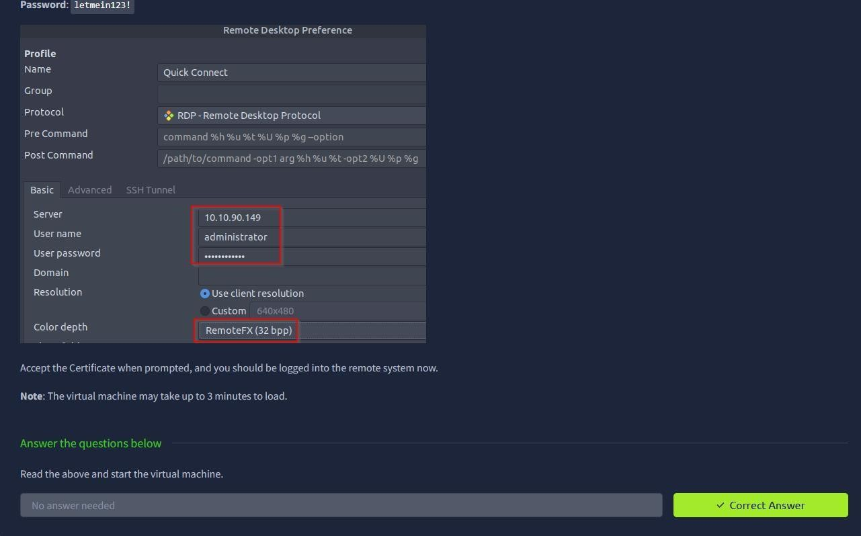

Task 2:

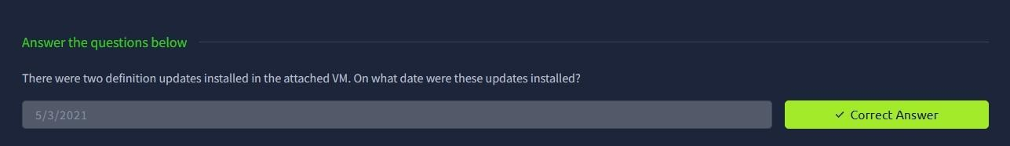

Task 3:

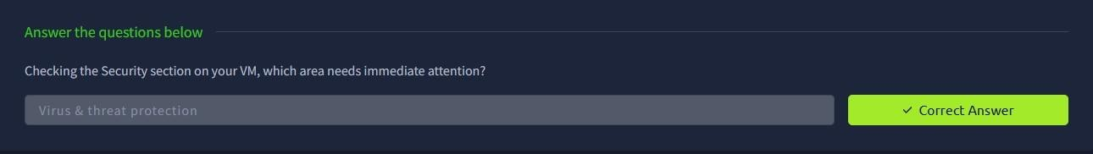

Task 4:

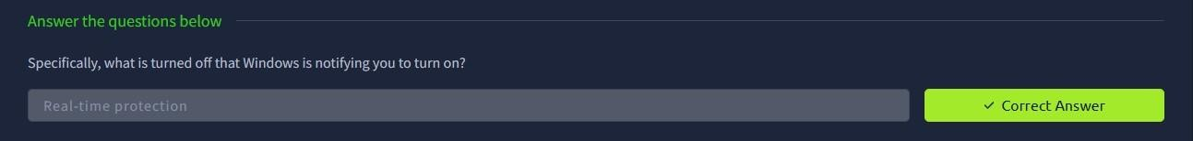

Task 5:

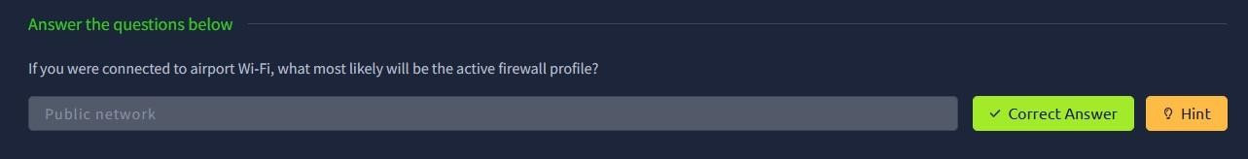

Task 6:

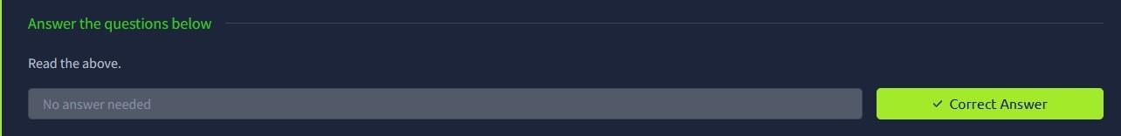

Task 7:

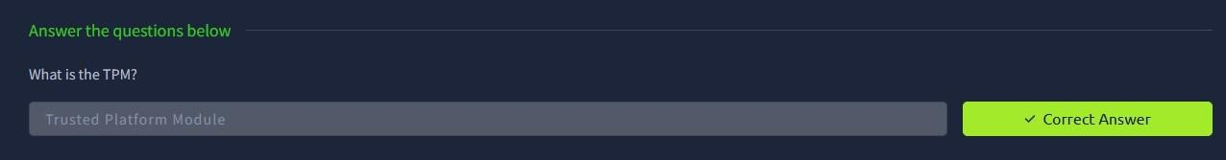

Task 8:

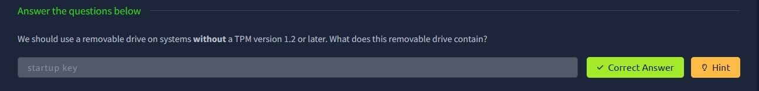

Task 9:

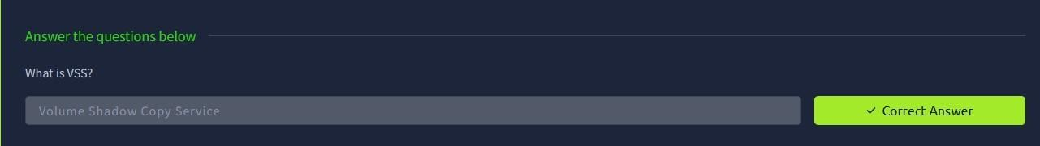

Task 10:

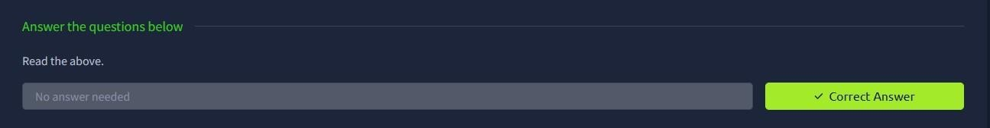

**RESULT:**

Thus the windows fundamentals 3 successfully completed in tryhackme platform.